Architecture Description of

CondoCare for

Condo Management System

**1 Introduction 3**

**1.1 Identifying information 3**

**1.2 Supplementary information 3**

**1.3 Other information 3**

**1.3.1 Overview 3**

**1.3.2 Architecture evaluations 3**

**1.3.3 Rationale for key decisions 3**

**2 Stakeholders and concerns 4**

**3 Viewpoints 5**

3.3.2 Typical Stakeholders 6

3.4 Model kinds 6

3.5 User Profile Model: 6

3.5.1 User Profile Model conventions: 6

3.5.2 User Profile Model correspondence rules: 6

3.6 Operations on views 6

3.2 Overview 7

3.3 Concerns and Stakeholders 7

3.3.1 Concerns 7

3.3.2 Typical Stakeholders 7

3.4 Model kinds 7

3.5 Property Model: 7

3.5.1 Property Model conventions: 7

3.5.2 Property Model correspondence rules: 7

3.5 Financial Overview Model: 7

3.5.1 Financial Overview Model conventions: 7

3.5.2 Financial Overview Model correspondence rules: 8

3.6 Operations on views 8

3.2 Overview 8

3.3 Concerns and Stakeholders 8

3.3.1 Concerns 8

3.3.2 Typical Stakeholders 8

3.4 Model kinds 9

3.5 Property Profile Model: 9

3.5.1 Property Profile Model conventions: 9

3.5.2 Property Profile Model correspondence rules: 9

3.5 Condo Files Model: 9

3.5.1 Condo Files Model conventions: 9

3.5.2 Condo Files Model correspondence rules: 9

3.5 Unit Information Model: 9

3.5.1 Unit Information Model conventions: 9

3.5.2 Unit Information Model correspondence rules: 9

3.6 Operations on views 10

3.2 Overview 10

3.3 Concerns and Stakeholders 10

3.3.1 Concerns 10

3.3.2 Typical Stakeholders 10

3.4 Model kinds 11

3.5 Condo Fees Calculation Model: 11

3.5.1 Condo Fees Calculation Model conventions: 11

3.5.2 Condo Fees Calculation Model correspondence rules: 11

● Correspondence rules ensure accurate links between fee components and their representation in the model. 11

3.5 Operational Budget Model: 11

3.5.1 Operational Budget Model conventions: 11

3.5.2 Operational Budget Model correspondence rules: 11

3.5 Costs Recording Model: 11

3.5.1 Costs Recording Model conventions: 11

3.5.2 Costs Recording Model correspondence rules: 11

3.5 Annual Financial Reports Model: 12

3.5.1 Annual Financial Reports Model conventions: 12

3.5.2 Annual Financial Reports Model correspondence rules: 12

3.6 Operations on views 12

3.2 Overview 12

3.3 Concerns and Stakeholders 13

3.3.1 Concerns 13

3.3.2 Typical Stakeholders 13

3.5 Reservation System Model: 13

3.5.1 Reservation System Model conventions: 13

3.5.2 Reservation System Model correspondence rules: 13

3.6 Operations on views 13

3.2 Overview 14

3.3 Concerns and Stakeholders 14

3.3.1 Concerns 14

3.3.2 Typical Stakeholders 14

3.4 Model kinds 14

3.5 Employee Roles Model: 14

3.5.1 Employee Roles Model conventions: 14

3.5.2 Employee Roles Model correspondence rules: 14

3.5 Permissions Model: 15

3.5.1 Permissions Model conventions: 15

3.5.2 Permissions Model correspondence rules: 15

3.6 Operations on views 15

3.2 Overview 15

3.3 Concerns and Stakeholders 16

3.3.1 Concerns 16

3.3.2 Typical Stakeholders 16

3.4 Model kinds 16

3.5 Scalability Assessment Model: 16

3.5.1 Scalability Assessment Model conventions: 16

3.5.2 Scalability Assessment Model correspondence rules: 16

3.5 User Interface Model: 16

3.5.1 User Interface Model conventions: 16

3.5.2 User Interface Model correspondence rules: 16

3.6 Operations on views 17

3.2 Overview 17

3.3 Concerns and Stakeholders 17

3.3.1 Concerns 17

3.3.2 Typical Stakeholders 17

3.4 Model kinds 17

3.5 Technical Feasibility Model: 17

3.5.1 Technical Feasibility Model conventions: 17

3.5.2 Technical Feasibility Model correspondence rules: 18

3.5 Operational Feasibility Model: 18

3.5.1 Operational Feasibility Model conventions: 18

3.5.2 Operational Feasibility Model correspondence rules: 18

3.6 Operations on views 18

3.2 Overview 19

3.3 Concerns and Stakeholders 19

3.3.1 Concerns 19

3.3.2 Typical Stakeholders 19

3.4 Model kinds 19

3.5 Risk Identification Model: 19

3.5.1 Risk Identification Model conventions: 19

3.5.2 Risk Identification Model correspondence rules: 19

3.5 Risk Mitigation Model: 19

3.5.1 Risk Mitigation Model conventions: 19

3.5.2 Risk Mitigation Model correspondence rules: 20

3.6 Operations on views 20

3.2 Overview 20

3.3 Concerns and Stakeholders 20

3.3.1 Concerns 20

3.3.2 Typical Stakeholders 20

3.4 Model kinds 21

3.5 Maintenance Plan Model: 21

3.5.1 Maintenance Plan Model conventions: 21

3.5.2 Maintenance Plan Model correspondence rules: 21

3.5 Evolution Plan Model: 21

3.5.1 Evolution Plan Model conventions: 21

3.5.2 Evolution Plan Model correspondence rules: 21

3.5 User Feedback Model: 21

3.5.1 User Feedback Model conventions: 21

3.5.2 User Feedback Model correspondence rules: 22

3.5 Technological Advancements Model: 22

3.5.1 Technological Advancements Model conventions: 22

3.5.2 Technological Advancements Model correspondence rules: 22

3.5 Feature Evolution Model: 22

3.5.1 Feature Evolution Model conventions: 22

3.5.2 Feature Evolution Model correspondence rules: 22

3.6 Operations on views 22

3.7 Correspondence rules 23

# 1 Introduction

This chapter describes introductory information items of the AD, including identifying and supplementary information.

## 1.1 Identifying information

**Architecture Name:** Condo Management System  
**System of Interest:** Simplified condo management app and companion website

## 1.2 Supplementary information

**Date of Issue:  
Status:   
Authors:  
Issuing Organization:  
Change History:  
Summary:** This document outlines the architecture of a Condo Management System, including key requirements, stakeholders, concerns, viewpoints, and views.

## 1.3 Other information

### 1.3.1 Overview

The Condo Management System is designed as a comprehensive solution to address the needs of condo management companies, condo owners, and rental users. This overview provides a glimpse into the architecture's essential points, purpose, scope, and context.  
  
**Purpose:** The primary purpose of the Condo Management System is to provide a centralized platform facilitating efficient communication and management processes between condo management companies, condo owners, and rental users.  
**Scope:** The architecture encompasses several key features, including profile creation, property management, financial tracking, reservation systems, and request handling. It extends its scope to cater to the diverse needs of stakeholders, ensuring a user-friendly and functional system.  
**Context:** The system operates within the context of the real estate industry, specifically focusing on the management of condominium properties.

**Overview of the Remainder of the AD:**The following sections will delve into stakeholders and their concerns, providing a detailed analysis of the key participants in the Condo Management System.  
Each subsequent section will offer insights into specific viewpoints, models, and architecture decisions, providing a comprehensive guide for the readers to navigate through the architecture description.

### 1.3.2 Architecture evaluations

A comprehensive evaluation has been conducted to assess the effectiveness and efficiency of the Condo Management System.  
The evaluation focused on aspects such as system performance, scalability, security, and user experience.  
Results from the evaluation are detailed in the respective section of this architecture description, providing valuable insights into the system's strengths and areas for improvement.

### 1.3.3 Rationale for key decisions

This section outlines and provides a rationale for decisions considered pivotal to the architecture of the Condo Management System.

Decisions related to system design, data management, security protocols, and user interactions have been thoroughly documented to ensure transparency and traceability.

Rationale includes stakeholder needs, system scalability, and alignment with industry best practices.

# 2 Stakeholders and concerns

This chapter contains information items for stakeholders of the architecture, the stakeholders’ concerns for that architecture, and the traceability of concerns to stakeholders.

2.1 Stakeholders

Stakeholders in the architecture encompass a diverse range, including individuals, groups, and organizations. It is essential to identify these stakeholders, considering their roles and interests. The following stakeholders are crucial for the Architecture Description (AD):  
  
Condo Owners  
Rental Users  
Condo Management Companies  
  
2.2 Concerns

**Purpose(s) of the System-of-Interest:**

* Enable public users (condo owners and rental users) to manage their profiles efficiently.
* Provide condo owners with a comprehensive view of their properties, financial status, and submitted requests.
* Allow condo management companies to create and manage property profiles, upload condo files, and enter detailed information for each unit, parking spot, and locker.
* Facilitate a simplified financial system, including the calculation and presentation of condo fees, recording of operational budget and costs, and generation of annual financial reports.
* Incorporate a reservation system for common facilities, allowing users to book facilities with ease.
* Support different roles for employees within condo management companies, such as managers responsible for daily operations or finance.

**Suitability of the Architecture:**

* The architecture should be designed to effectively achieve the identified purposes of the condo management system.
* It should ensure scalability to handle a growing number of users, properties, and associated data.
* The architecture must provide a user-friendly interface for various stakeholders, considering their diverse roles and responsibilities.
* Compatibility with relevant technologies and platforms is crucial to enhance accessibility and usability.
* Feasibility of Construction and Deployment:
* The system's construction and deployment should be feasible within the defined project constraints.
* Consideration should be given to the technical feasibility, ensuring that the chosen technologies can support the required functionalities.
* Operational feasibility should be assessed to ensure that the system aligns with the organization's processes and can be seamlessly integrated into existing workflows.

**Potential Risks and Impacts:**

* Data security and privacy concerns, especially given the sensitive nature of condo-related information.
* Challenges in user adoption and engagement.
* Technical challenges during construction and deployment.
* Legal and compliance risks related to data handling and financial transactions.
* Assess the potential impacts of these risks on stakeholders, ensuring proactive mitigation strategies are in place.

**Maintenance and Evolution:**

* Establish a plan for the ongoing maintenance and evolution of the system:
* Regular updates and patches to address security vulnerabilities and improve system performance.
* Continuous monitoring and improvement of user experience based on feedback.
* Adaptation to technological advancements to ensure long-term sustainability.
* Evolution of features and functionalities to meet changing user needs and industry standards.

2.3 Concern–Stakeholder Traceability

Table 2.1: Table Showing the association of stakeholders to concerns in an AD

|  | Condo Owners | Rental users | Condo Management Comapnies |
| --- | --- | --- | --- |
| Profile | X | X | – |
| Dashboard | X | X | – |
| Property Management | X | X | – |
| Financial System | X | X | – |
| Reservation System | X | X | – |
| Employee Roles | X | X | – |
| Security | – | – | X |
| User Adoption & Engagement | – | – | X |
| Technical Challenges | – | – | X |
| Legal & Compliance Risk | – | – | X |
| Data Handling | – | – | X |
| Maintenance | – | – | X |

# 3 Viewpoints

Profile Management Viewpoint:

3.2 Overview  
This viewpoint focuses on the efficient management of profiles for public users, including condo owners and rental users.

3.3 Concerns and Stakeholders

3.3.1 Concerns  
 Efficient profile management for condo owners and rental users.

### 3.3.2 Typical Stakeholders

Condo owners

Rental users

## 3.4 Model kinds

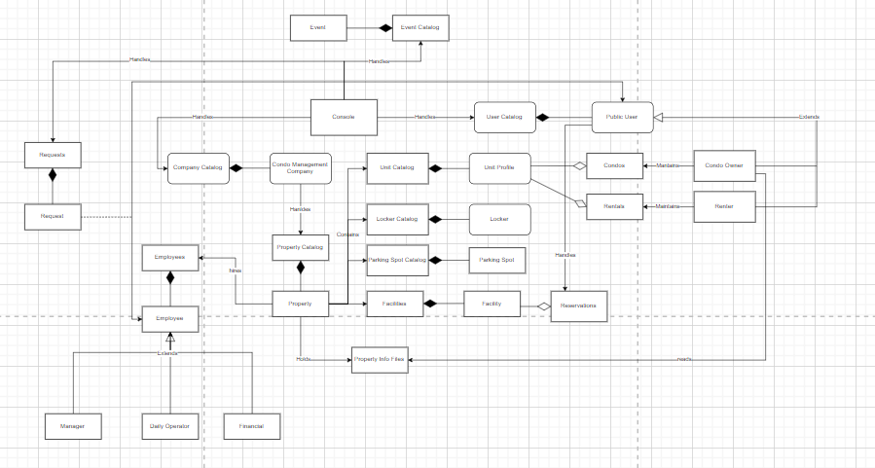

## 3.5 User Profile Model:

### 3.5.1 User Profile Model conventions:

* + The User Profile Model utilizes the Unified Modeling Language (UML) notation to represent the various components of a user profile.
  + Conventions also involve the use of stereotypes within the UML notation to distinguish between different types of users and their respective profile characteristics.
  + Analytical methods may include evaluating the user profile model for completeness, consistency, and conformity to predefined standards.

### 3.5.2 User Profile Model correspondence rules:

* + Correspondence rules dictate that each user profile instance must be associated with a unique username and password combination.
  + The correspondence between the User Profile Model and other related models, such as the Employee Roles Model, should be defined to establish the permissions and access levels associated with each user profile.
  + Changes in user roles or permissions should be reflected in the User Profile Model, ensuring synchronization with the Employee Roles Model.

## 3.6 Operations on views

* **Construction Methods:**
  + Construction methods involve providing process guidance for efficiently managing profiles for public users, including condo owners and rental users.
  + Templates for constructing user profiles, considering different user types, and capturing necessary information.
* **Interpretation Methods:**
  + Interpretation methods guide readers in understanding the constructed user profiles, their attributes, and the distinctions between various user types.
  + Heuristic guidance for interpreting patterns or styles used in synthesizing user profiles.
* **Analysis Methods:**
  + Analysis methods are applied to check the completeness, consistency, and conformity of user profiles.
  + Model correspondence rules are checked to ensure accurate associations between user profiles and related entities.
* **Implementation Methods:**
  + Implementation methods focus on the design and integration of the user profile model into the broader system.
  + Guidance on incorporating user profiles into the overall system design and functionality.

Property and Financial Overview Viewpoint:

## 3.2 Overview

This viewpoint provides a comprehensive view of properties, financial status, and submitted requests for condo owners.

## 3.3 Concerns and Stakeholders

### 3.3.1 Concerns

Comprehensive property and financial overview.

### 3.3.2 Typical Stakeholders

Condo owners

## 3.4 Model kinds

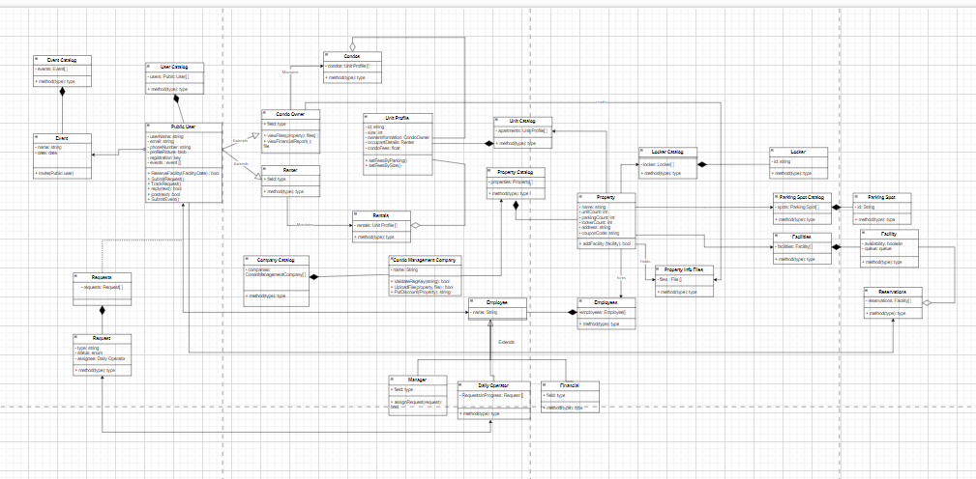

## 3.5 Property Model:

### 3.5.1 Property Model conventions:

* + The Property Model employs UML class diagrams to represent the structure of properties, financial status, and submitted requests.
  + Conventions include defining classes for properties, relationships for financial status, and associations for submitted requests.

### 3.5.2 Property Model correspondence rules:

* + Correspondence rules ensure that each property instance is associated with accurate financial status information.
  + Changes in property details or financial status should be reflected in the Property Model to maintain data integrity.

## 3.5 Financial Overview Model:

### 3.5.1 Financial Overview Model conventions:

* + The Financial Overview Model utilizes UML notation, focusing on class diagrams to represent financial components.
  + Conventions involve defining classes for condo fees, operational budget, costs, and annual financial reports.

### 3.5.2 Financial Overview Model correspondence rules:

* + Correspondence rules ensure accurate links between financial components and their representation in the model.
  + Changes in financial calculations or reporting should be reflected in the Financial Overview Model.

## 3.6 Operations on views

* **Construction Methods:**
  + Construction methods involve process guidance for creating a comprehensive view of properties, financial status, and submitted requests for condo owners.
  + Templates for representing property and financial information.
* **Interpretation Methods:**
  + Interpretation methods guide readers in understanding the relationships between properties, financial status, and submitted requests.
  + Heuristic guidance for interpreting patterns or styles used in synthesizing property and financial overviews.
* **Analysis Methods:**
  + Analysis methods are applied to check the consistency of property and financial information.
  + Model correspondence rules are checked to ensure accurate associations between properties and financial components.
* **Implementation Methods:**
  + Implementation methods focus on designing and implementing the property and financial overview model into the broader system.
  + Guidance on incorporating property and financial information into the overall system design and functionality.

Property Management Viewpoint:

## 3.2 Overview

This viewpoint focuses on creating and managing property profiles, uploading condo files, and entering detailed information for each unit, parking spot, and locker.

## 3.3 Concerns and Stakeholders

### 3.3.1 Concerns

Efficient property management.

### 3.3.2 Typical Stakeholders

Condo management companies

## 3.4 Model kinds

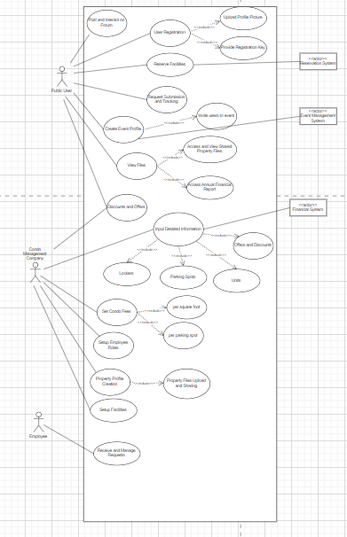

## 3.5 Property Profile Model:

### 3.5.1 Property Profile Model conventions:

* + The Property Profile Model uses UML class diagrams to depict the structure of property profiles, condo files, unit information, and related details.
  + Conventions include defining classes for property profiles, associations for condo files, and attributes for unit information.

### 3.5.2 Property Profile Model correspondence rules:

* + Correspondence rules ensure that each property profile is associated with accurate condo files and unit information.
  + Changes in property details, condo files, or unit information should be reflected in the Property Profile Model.

## 3.5 Condo Files Model:

### 3.5.1 Condo Files Model conventions:

* + The Condo Files Model employs UML class diagrams to represent the structure of files associated with condos.
  + Conventions include defining classes for file details, associations for related condos, and attributes for file information.

### 3.5.2 Condo Files Model correspondence rules:

* + Correspondence rules ensure accurate associations between condo files and related condos.
  + Changes in file details or associations should be reflected in the Condo Files Model.

## 3.5 Unit Information Model:

### 3.5.1 Unit Information Model conventions:

* + The Unit Information Model uses UML class diagrams to represent the structure of detailed information for each unit.
  + Conventions include defining classes for unit details, attributes for specifications, and associations for related properties.

### 3.5.2 Unit Information Model correspondence rules:

* + Correspondence rules ensure that each unit instance is associated with accurate details and related property information.
  + Changes in unit specifications or associations should be reflected in the Unit Information Model.

## 3.6 Operations on views

* **Construction Methods:**
  + Construction methods involve process guidance for creating and managing property profiles, uploading condo files, and entering detailed information for each unit, parking spot, and locker.
  + Templates for representing property profiles, condo files, and unit information.
* **Interpretation Methods:**
  + Interpretation methods guide readers in understanding the relationships between property profiles, condo files, and unit information.
  + Heuristic guidance for interpreting patterns or styles used in synthesizing property management information.
* **Analysis Methods:**
  + Analysis methods are applied to check the efficiency of property management processes.
  + Model correspondence rules are checked to ensure accurate associations between property profiles, condo files, and unit information.
* **Implementation Methods:**
  + Implementation methods focus on designing and implementing the property management model into the broader system.
  + Guidance on incorporating property management information into the overall system design and functionality.

Financial System Viewpoint:

## 3.2 Overview

This viewpoint facilitates a simplified financial system, including the calculation and presentation of condo fees, recording of operational budget and costs, and generation of annual financial reports.

## 3.3 Concerns and Stakeholders

### 3.3.1 Concerns

Simplified financial system

### 3.3.2 Typical Stakeholders

Condo management companies

## 3.4 Model kinds

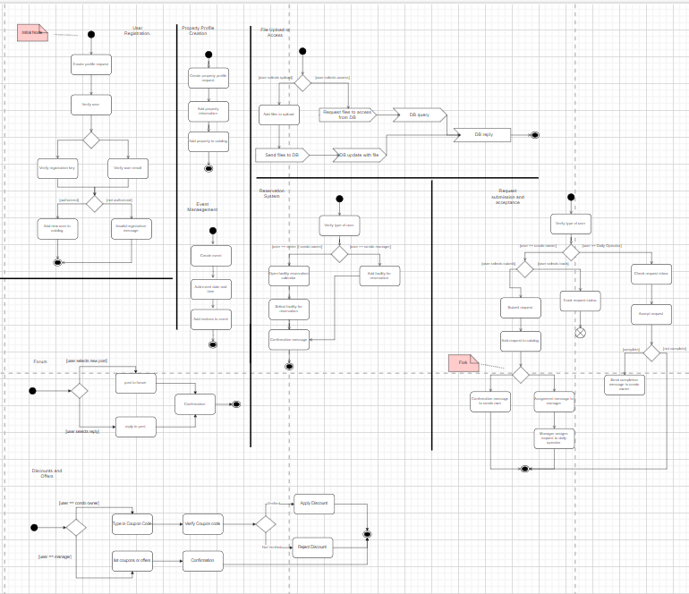

## 3.5 Condo Fees Calculation Model:

### 3.5.1 Condo Fees Calculation Model conventions:

* + The Condo Fees Calculation Model utilizes UML class diagrams to depict the structure of calculations related to condo fees.
  + Conventions involve defining classes for fee components, associations for related properties, and attributes for calculation details.

### 3.5.2 Condo Fees Calculation Model correspondence rules:

### Correspondence rules ensure accurate links between fee components and their representation in the model.

* + Changes in fee calculations or related property details should be reflected in the Condo Fees Calculation Model.

## 3.5 Operational Budget Model:

### 3.5.1 Operational Budget Model conventions:

* + The Operational Budget Model employs UML class diagrams to represent the structure of operational budget components.
  + Conventions include defining classes for budget categories, associations for related properties, and attributes for budget details.

### 3.5.2 Operational Budget Model correspondence rules:

* + Correspondence rules ensure accurate associations between budget components and related properties.
  + Changes in budget categories or property associations should be reflected in the Operational Budget Model.

## 3.5 Costs Recording Model:

### 3.5.1 Costs Recording Model conventions:

* + The Costs Recording Model uses UML class diagrams to represent the structure of recording costs associated with condo management.
  + Conventions involve defining classes for cost entries, associations for related properties, and attributes for cost details.

### 3.5.2 Costs Recording Model correspondence rules:

* + Correspondence rules ensure accurate links between cost entries and related properties.
  + Changes in cost details or property associations should be reflected in the Costs Recording Model.

## 3.5 Annual Financial Reports Model:

### 3.5.1 Annual Financial Reports Model conventions:

* + The Annual Financial Reports Model utilizes UML class diagrams to represent the structure of generating annual financial reports.
  + Conventions include defining classes for report components, associations for related properties, and attributes for report details.

### 3.5.2 Annual Financial Reports Model correspondence rules:

* + Correspondence rules ensure accurate associations between report components and related properties.
  + Changes in report details or property associations should be reflected in the Annual Financial Reports Model.

## 3.6 Operations on views

* **Construction Methods:**
  + Construction methods involve process guidance for creating a simplified financial system, including the calculation and presentation of condo fees, recording of operational budget and costs, and generation of annual financial reports.
  + Templates for representing condo fees, operational budget, costs, and financial reports.
* **Interpretation Methods:**
  + Interpretation methods guide readers in understanding the relationships between financial components and the overall financial system.
  + Heuristic guidance for interpreting patterns or styles used in synthesizing financial information.
* **Analysis Methods:**
  + Analysis methods are applied to check the accuracy and simplicity of financial calculations and reporting.
  + Model correspondence rules are checked to ensure accurate associations between financial components.
* **Implementation Methods:**
  + Implementation methods focus on designing and implementing the financial system model into the broader system.
  + Guidance on incorporating financial information into the overall system design and functionality.

Reservation System Viewpoint:

## 3.2 Overview

This viewpoint incorporates a reservation system for common facilities, allowing users to book facilities with ease.

## 3.3 Concerns and Stakeholders

### 3.3.1 Concerns

Efficient reservation system

### 3.3.2 Typical Stakeholders

Condo owners

Rental users

3.4 Model kinds

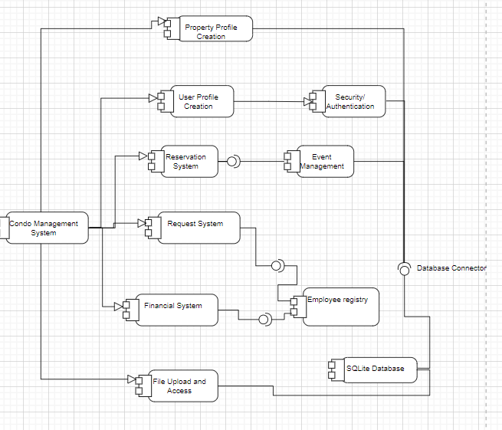

## 3.5 Reservation System Model:

### 3.5.1 Reservation System Model conventions:

* + The Reservation System Model employs UML class diagrams to represent the structure of reservations for common facilities.
  + Conventions include defining classes for reservation details, associations for related properties, and attributes for reservation information.

### 3.5.2 Reservation System Model correspondence rules:

* + Correspondence rules ensure accurate links between reservations and related properties.
  + Changes in reservation details or property associations should be reflected in the Reservation System Model.

## 3.6 Operations on views

* **Construction Methods:**
  + Construction methods involve process guidance for incorporating a reservation system for common facilities, allowing users to book facilities with ease.
  + Templates for representing reservation details and associated properties.
* **Interpretation Methods:**
  + Interpretation methods guide readers in understanding the relationships between reservations and properties.
  + Heuristic guidance for interpreting patterns or styles used in synthesizing reservation information.
* **Analysis Methods:**
  + Analysis methods are applied to check the efficiency of the reservation system and its integration with the overall system.
  + Model correspondence rules are checked to ensure accurate associations between reservations and properties.
* **Implementation Methods:**
  + Implementation methods focus on designing and implementing the reservation system model into the broader system.
  + Guidance on incorporating reservation information into the overall system design and functionality.

Employee Roles and Permissions Viewpoint:

## 3.2 Overview

This viewpoint supports different roles for employees within condo management companies, such as managers responsible for daily operations or finance.

## 3.3 Concerns and Stakeholders

### 3.3.1 Concerns

Effective employee roles and permissions.

### 3.3.2 Typical Stakeholders

Employees within condo management companies

## 3.4 Model kinds

## 3.5 Employee Roles Model:

### 3.5.1 Employee Roles Model conventions:

* + The Employee Roles Model uses UML class diagrams to depict the structure of different roles for employees within condo management companies.
  + Conventions involve defining classes for role specifications, associations for related employees, and attributes for role details.

### 3.5.2 Employee Roles Model correspondence rules:

* + Correspondence rules ensure accurate associations between roles and related employees.
  + Changes in role specifications or employee associations should be reflected in the Employee Roles Model.

## 3.5 Permissions Model:

### 3.5.1 Permissions Model conventions:

* + The Permissions Model employs UML class diagrams to represent the structure of permissions associated with different roles.
  + Conventions include defining classes for permission details, associations for related roles, and attributes for permission specifications.

### 3.5.2 Permissions Model correspondence rules:

* + Correspondence rules ensure accurate links between permissions and related roles.
  + Changes in permission specifications or role associations should be reflected in the Permissions Model.

## 3.6 Operations on views

* **Construction Methods:**
  + Construction methods involve process guidance for supporting different roles for employees within condo management companies.
  + Templates for representing employee roles and permissions.
* **Interpretation Methods:**
  + Interpretation methods guide readers in understanding the relationships between employee roles, permissions, and related entities.
  + Heuristic guidance for interpreting patterns or styles used in synthesizing employee-related information.
* **Analysis Methods:**
  + Analysis methods are applied to check the effectiveness of employee roles and permissions.
  + Model correspondence rules are checked to ensure accurate associations between roles, permissions, and related entities.
* **Implementation Methods:**
  + Implementation methods focus on designing and implementing the employee roles and permissions model into the broader system.
  + Guidance on incorporating employee-related information into the overall system design and functionality.

Scalability and Accessibility Viewpoint:

## 3.2 Overview

This viewpoint ensures scalability to handle a growing number of users, properties, and associated data. It also focuses on providing a user-friendly interface for various stakeholders.

## 3.3 Concerns and Stakeholders

### 3.3.1 Concerns

System scalability and user-friendly interface.

### 3.3.2 Typical Stakeholders

All users and stakeholders

## 3.4 Model kinds

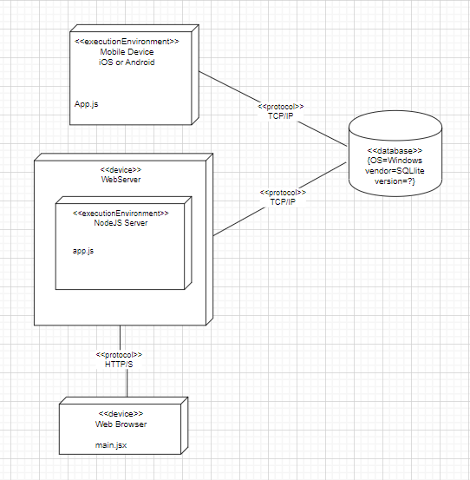

## 3.5 Scalability Assessment Model:

### 3.5.1 Scalability Assessment Model conventions:

* + The Scalability Assessment Model uses UML class diagrams to represent the scalability considerations for handling a growing number of users and properties.
  + Conventions involve defining classes for scalability components, associations for related systems, and attributes for scalability details.

### 3.5.2 Scalability Assessment Model correspondence rules:

* + Correspondence rules ensure accurate links between scalability components and related systems.
  + Changes in scalability considerations or system associations should be reflected in the Scalability Assessment Model.

## 3.5 User Interface Model:

### 3.5.1 User Interface Model conventions:

* + The User Interface Model employs UML class diagrams or wireframes to represent the design and structure of a user-friendly interface.
  + Conventions include defining classes for interface elements, associations for user interactions, and attributes for interface specifications.

### 3.5.2 User Interface Model correspondence rules:

* + Correspondence rules ensure accurate links between interface elements and user interactions.
  + Changes in interface specifications or user interactions should be reflected in the User Interface Model.

## 3.6 Operations on views

* **Construction Methods:**
  + Construction methods involve process guidance for ensuring scalability to handle a growing number of users, properties, and associated data.
  + Templates for representing scalability components and user-friendly interfaces.
* **Interpretation Methods:**
  + Interpretation methods guide readers in understanding the relationships between scalability components, user interfaces, and overall system accessibility.
  + Heuristic guidance for interpreting patterns or styles used in synthesizing scalability and accessibility information.
* **Analysis Methods:**
  + Analysis methods are applied to check the scalability and user-friendliness of the system.
  + Model correspondence rules are checked to ensure accurate associations between scalability components and user interfaces.
* **Implementation Methods:**
  + Implementation methods focus on designing and implementing the scalability and accessibility model into the broader system.
  + Guidance on incorporating scalability and accessibility information into the overall system design and functionality.

Feasibility Assessment Viewpoint:

## 3.2 Overview

This viewpoint assesses the feasibility of constructing and deploying the system within defined project constraints.

## 3.3 Concerns and Stakeholders

### 3.3.1 Concerns

Technical and operational feasibility.

### 3.3.2 Typical Stakeholders

Project stakeholders

## 3.4 Model kinds

## 3.5 Technical Feasibility Model:

### 3.5.1 Technical Feasibility Model conventions:

* + The Technical Feasibility Model uses UML diagrams to represent technical aspects, ensuring that chosen technologies can support required functionalities.
  + Conventions involve defining classes for technical components, associations for relevant technologies, and attributes for technical details.

### 3.5.2 Technical Feasibility Model correspondence rules:

* + Correspondence rules ensure accurate links between technical components and relevant technologies.
  + Changes in technical details or technology associations should be reflected in the Technical Feasibility Model.

## 3.5 Operational Feasibility Model:

### 3.5.1 Operational Feasibility Model conventions:

* + The Operational Feasibility Model uses UML diagrams to assess the alignment of the system with organizational processes.
  + Conventions involve defining classes for operational components, associations for organizational processes, and attributes for operational details.

### 3.5.2 Operational Feasibility Model correspondence rules:

* + Correspondence rules ensure accurate links between operational components and organizational processes.
  + Changes in operational details or process associations should be reflected in the Operational Feasibility Model.

## 3.6 Operations on views

* **Construction Methods:**
  + Construction methods involve process guidance for assessing the feasibility of constructing and deploying the system within defined project constraints.
  + Templates for representing technical and operational feasibility components.
* **Interpretation Methods:**
  + Interpretation methods guide readers in understanding the relationships between feasibility components and project constraints.
  + Heuristic guidance for interpreting patterns or styles used in synthesizing feasibility information.
* **Analysis Methods:**
  + Analysis methods are applied to check the technical and operational feasibility of the system.
  + Model correspondence rules are checked to ensure accurate associations between feasibility components and project constraints.
* **Implementation Methods:**
  + Implementation methods focus on designing and implementing the feasibility assessment model into the broader system.
  + Guidance on incorporating feasibility information into the overall system design and functionality.

Risk Management Viewpoint:

## 3.2 Overview

This viewpoint identifies and addresses potential risks and impacts related to data security, user adoption, technical challenges, legal and compliance issues.

## 3.3 Concerns and Stakeholders

### 3.3.1 Concerns

Risk identification and mitigation.

### 3.3.2 Typical Stakeholders

All stakeholders

## 3.4 Model kinds

## 3.5 Risk Identification Model:

### 3.5.1 Risk Identification Model conventions:

* + The Risk Identification Model uses UML diagrams to identify potential risks related to data security, user adoption, technical challenges, and legal issues.
  + Conventions involve defining classes for risk components, associations for risk factors, and attributes for risk details.

### 3.5.2 Risk Identification Model correspondence rules:

* + Correspondence rules ensure accurate links between risk components and relevant risk factors.
  + Changes in risk details or factors should be reflected in the Risk Identification Model.

## 3.5 Risk Mitigation Model:

### 3.5.1 Risk Mitigation Model conventions:

* + The Risk Mitigation Model uses UML diagrams to outline strategies and actions for mitigating identified risks.
  + Conventions involve defining classes for mitigation components, associations for risk factors, and attributes for mitigation details.

### 3.5.2 Risk Mitigation Model correspondence rules:

* + Correspondence rules ensure accurate links between mitigation components and relevant risk factors.
  + Changes in mitigation details or risk factors should be reflected in the Risk Mitigation Model.

## 3.6 Operations on views

* **Construction Methods:**
  + Construction methods involve process guidance for identifying and addressing potential risks and impacts related to data security, user adoption, technical challenges, legal, and compliance issues.
  + Templates for representing risk identification and mitigation components.
* **Interpretation Methods:**
  + Interpretation methods guide readers in understanding the relationships between risk components and potential impacts.
  + Heuristic guidance for interpreting patterns or styles used in synthesizing risk-related information.
* **Analysis Methods:**
  + Analysis methods are applied to check the effectiveness of risk identification and mitigation strategies.
  + Model correspondence rules are checked to ensure accurate associations between risk components and potential impacts.
* **Implementation Methods:**
  + Implementation methods focus on designing and implementing the risk management model into the broader system.
  + Guidance on incorporating risk-related information into the overall system design and functionality.

Maintenance and Evolution Viewpoint:

## 3.2 Overview

This viewpoint establishes a plan for the ongoing maintenance and evolution of the system, including regular updates, monitoring, adaptation to technological advancements, and feature evolution.

## 3.3 Concerns and Stakeholders

### 3.3.1 Concerns

Ongoing maintenance and system evolution.

### 3.3.2 Typical Stakeholders

System administrators, developers, and users

## 3.4 Model kinds

## 3.5 Maintenance Plan Model:

### 3.5.1 Maintenance Plan Model conventions:

* + The Maintenance Plan Model uses UML diagrams to outline plans for regular updates, patches, and system improvements.
  + Conventions involve defining classes for maintenance components, associations for update plans, and attributes for maintenance details.

### 3.5.2 Maintenance Plan Model correspondence rules:

* + Correspondence rules ensure accurate links between maintenance components and update plans.
  + Changes in maintenance details or update plans should be reflected in the Maintenance Plan Model.

## 3.5 Evolution Plan Model:

### 3.5.1 Evolution Plan Model conventions:

* + The Evolution Plan Model uses UML diagrams to outline plans for adapting to technological advancements and ensuring long-term sustainability.
  + Conventions involve defining classes for evolution components, associations for adaptation plans, and attributes for evolution details.

### 3.5.2 Evolution Plan Model correspondence rules:

* + Correspondence rules ensure accurate links between evolution components and adaptation plans.
  + Changes in evolution details or adaptation plans should be reflected in the Evolution Plan Model.

## 3.5 User Feedback Model:

### 3.5.1 User Feedback Model conventions:

* + The User Feedback Model uses UML diagrams to capture feedback from users for continuous improvement.
  + Conventions involve defining classes for feedback components, associations for user interactions, and attributes for feedback details.

### 3.5.2 User Feedback Model correspondence rules:

* + Correspondence rules ensure accurate links between feedback components and user interactions.
  + Changes in feedback details or user interactions should be reflected in the User Feedback Model.

## 3.5 Technological Advancements Model:

### 3.5.1 Technological Advancements Model conventions:

* + The Technological Advancements Model uses UML diagrams to assess and incorporate advancements in technology.
  + Conventions involve defining classes for technological components, associations for relevant advancements, and attributes for technological details.

### 3.5.2 Technological Advancements Model correspondence rules:

* + Correspondence rules ensure accurate links between technological components and relevant advancements.
  + Changes in technological details or advancements should be reflected in the Technological Advancements Model.

## 3.5 Feature Evolution Model:

### 3.5.1 Feature Evolution Model conventions:

* + The Feature Evolution Model uses UML diagrams to outline plans for evolving features to meet changing user needs and industry standards.
  + Conventions involve defining classes for feature components, associations for evolving plans, and attributes for feature evolution details.

### 3.5.2 Feature Evolution Model correspondence rules:

* + Correspondence rules ensure accurate links between feature components and evolving plans.
  + Changes in feature details or evolving plans should be reflected in the Feature Evolution Model.

## 3.6 Operations on views

* **Construction Methods:**
  + Construction methods involve process guidance for establishing a plan for the ongoing maintenance and evolution of the system.
  + Templates for representing maintenance and evolution plans, user feedback, technological advancements, and feature evolution.
* **Interpretation Methods:**
  + Interpretation methods guide readers in understanding the relationships between maintenance and evolution components, user feedback, technological advancements, and feature evolution.
  + Heuristic guidance for interpreting patterns or styles used in synthesizing maintenance and evolution-related information.
* **Analysis Methods:**
  + Analysis methods are applied to check the effectiveness of maintenance and evolution plans, user feedback, and adaptation to technological advancements.
  + Model correspondence rules are checked to ensure accurate associations between maintenance and evolution components and relevant entities.
* **Implementation Methods:**
  + Implementation methods focus on designing and implementing the maintenance and evolution model into the broader system.
  + Guidance on incorporating maintenance and evolution-related information into the overall system design and functionality.

## 3.7 Correspondence rules

**User Profile Model**

* **Association with Roles and Permissions:**
  + Each user profile must be associated with the appropriate roles and permissions.
  + Correspondence between user profiles and roles/permissions must be maintained for access control.
* **Linkage to Property and Financial Information:**
  + Condo owners' profiles should be linked to their respective property and financial information.
  + Correspondence rules to ensure accurate representation of the relationship between user profiles and property/financial data.

**Property Model**

* **Connection with Property Profiles:**
  + Each property entity within the property model should correspond to a specific property profile.
  + Ensuring that the information in the property model aligns with the details in the property profiles.
* **Association with Financial Overview:**
  + Correspondence between properties and their financial overview, ensuring consistency in financial data representation.

**Property Profile Model**

* **Linkage with Unit Information:**
  + Property profiles should accurately link to unit information, parking spots, and locker details.
  + Ensuring that the property profile model correctly represents the property's attributes.
* **Connection with Condo Files:**
  + Correspondence rules to ensure that condo files are appropriately associated with the relevant property profiles.

**Condo Fees Calculation Model**

* **Association with Property Profiles:**
  + Correspondence between condo fees calculation and property profiles to determine the fees for each property accurately.
* **Linkage with Operational Budget:**
  + Ensuring that condo fees calculation corresponds appropriately with the operational budget model.

**Reservation System Model**

* **Connection with Property Details:**
  + Each reservation should correspond to specific property details.
  + Ensuring accurate representation of reservations in conjunction with the associated properties.

**Employee Roles Model**

* **Association with Permissions:**
  + Each employee role should correspond to the appropriate permissions.
  + Ensuring that employees with specific roles have the corresponding permissions.
* **Linkage with Operational Processes:**
  + Correspondence rules between employee roles and the operational processes they are responsible for.

**Scalability Assessment Model**

* **Connection with User Interface:**
  + Correspondence rules between the scalability assessment model and the user interface model.
  + Ensuring that the system's scalability aligns with the user-friendly interface.

**Technical Feasibility Model**

* **Correspondence with Chosen Technologies:**
  + Ensuring that the technical feasibility model corresponds accurately with the chosen technologies for system construction.

**Risk Identification Model**

* **Association with Mitigation Strategies:**
  + Correspondence between identified risks and the mitigation strategies outlined in the risk mitigation model.

**Maintenance Plan Model**

* **Linkage with User Feedback:**
  + Correspondence rules between the maintenance plan model and user feedback model.
  + Incorporating user feedback into the maintenance plan for continuous improvement.